**Developer Manual**

Contents

**System Requirements** 3

**Tools and Technologies** 3

**Installation Instructions** 3

**Python Installation** 3

**NodeJS Installation** 5

**Twitter Developer Account Setup** 9

**Steps for execution** 12

**Glossary of Errors** 12

# **System Requirements**

**Recommended System Requirements**

Processors:

* Intel® Core™ i5 processor 4300M at 2.60 GHz or 2.59 GHz (1 socket, 2 cores, 2 threads per core), 8 GB of DRAM
* Intel® Xeon® processor E5-2698 v3 at 2.30 GHz (2 sockets, 16 cores each, 1 thread per core), 64 GB of DRAM
* Intel® Xeon Phi™ processor 7210 at 1.30 GHz (1 socket, 64 cores, 4 threads per core), 32 GB of DRAM, 16 GB of MCDRAM (flat mode enabled)

Disk space: 2 to 3 GB

Operating systems: Windows® 10, macOS*, and Linux*

**Minimum System Requirements**

Processors: Intel Atom® processor or Intel® Core™ i3 processor

Disk space: 1 GB

Operating systems: Windows* 7 or later, macOS, and Linux

# **Tools and Technologies**

* Python - 3.6.X
* Google Docs
* Microsoft Visual Studio Code
* Python packages
  + Tweepy – 3.6.0
  + Twarc – 1.6.1
  + NLTK - 3.3

# **Installation Instructions**

## **Python Installation**

1. Go to Link: <https://www.python.org/getit/>

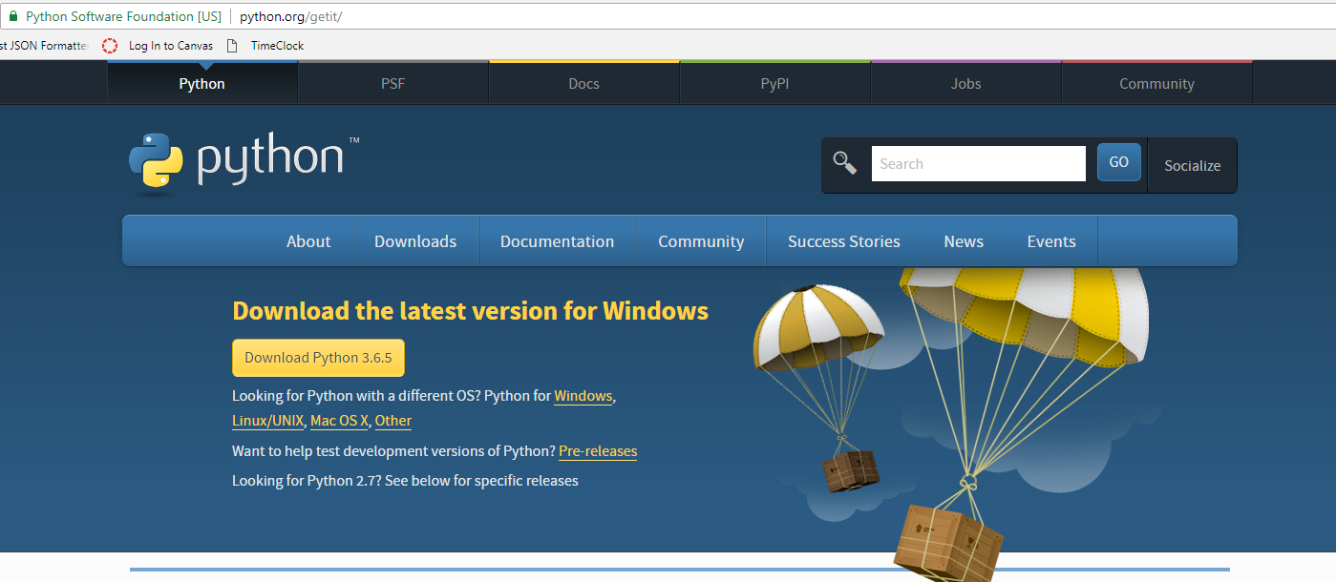

1. Click on the Download the Python 3.6.5 button.
2. A file starts downloading.
3. Open the downloaded file
4. Mark Add python 3.6 to PATH option and click on **Install now**

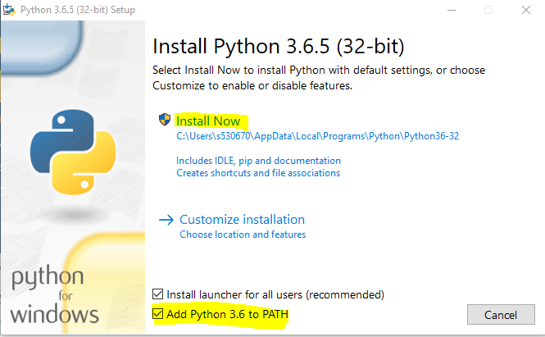

1. After successful installation you will see below screen

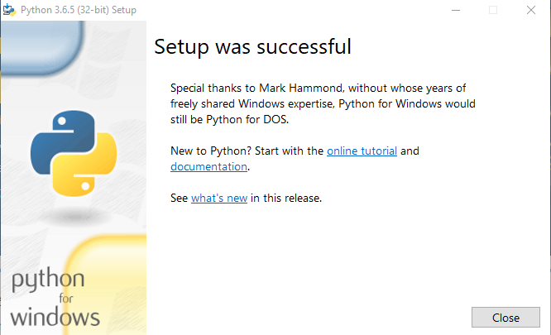

1. Open GitBash terminal or Command prompt anywhere on desktop and check the version by entering command **python –version**

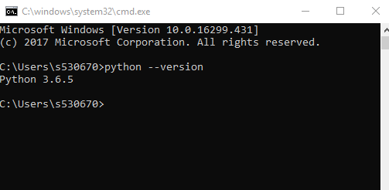

## **NodeJS Installation**

1. Go to Link: <https://nodejs.org/en/download/>

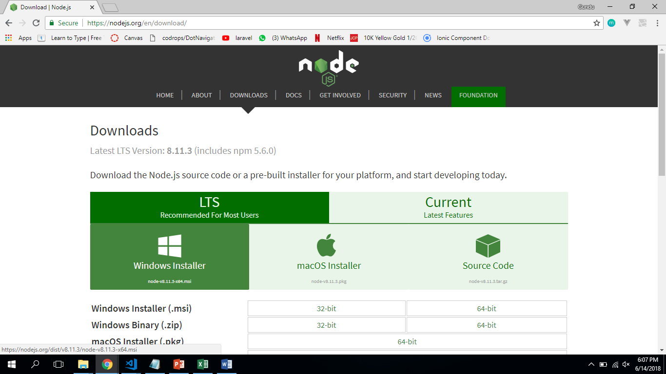

1. Select Windows Installer and you will be able to notice a file starts downloading.
2. Open and setup the downloaded file.

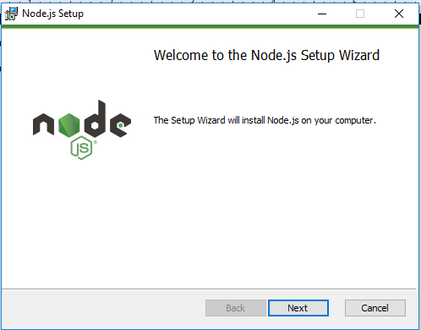

1. Proceed till you install the NodeJS

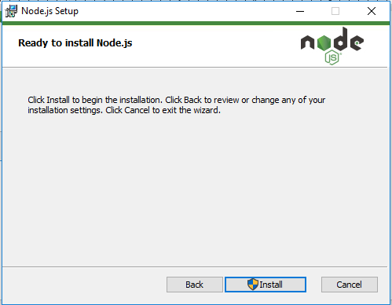

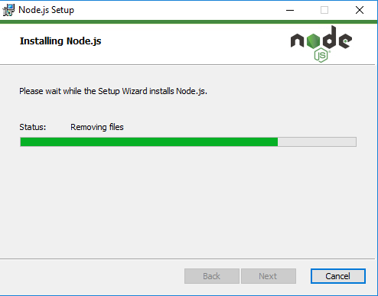

1. After setting up the NodeJS you will be able to see the below screen

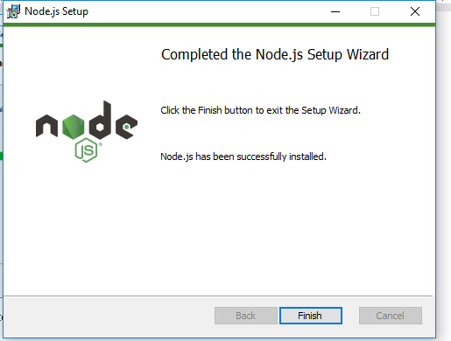

1. Open GitBash terminal or Command prompt anywhere on desktop and check the version by entering command $node -v

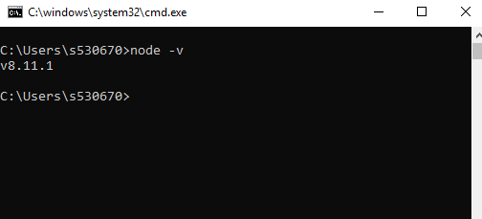

## **Twitter Developer Account Setup**

1. Go to Link: <https://apps.twitter.com> and click on sign in. (If you don’t have twitter account, please sign up for it).

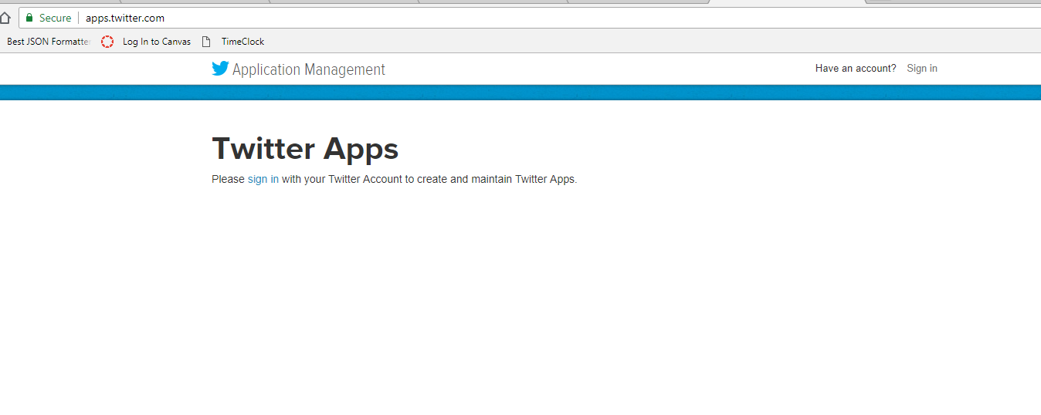

1. Sign in with your Twitter account

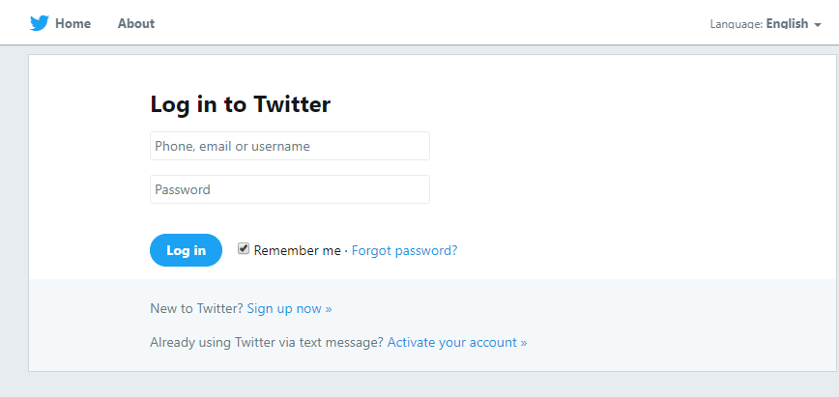

1. Click on **Create New App**

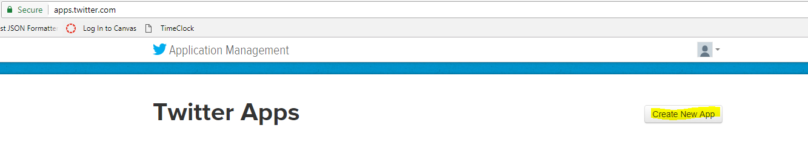

1. Fill in application details

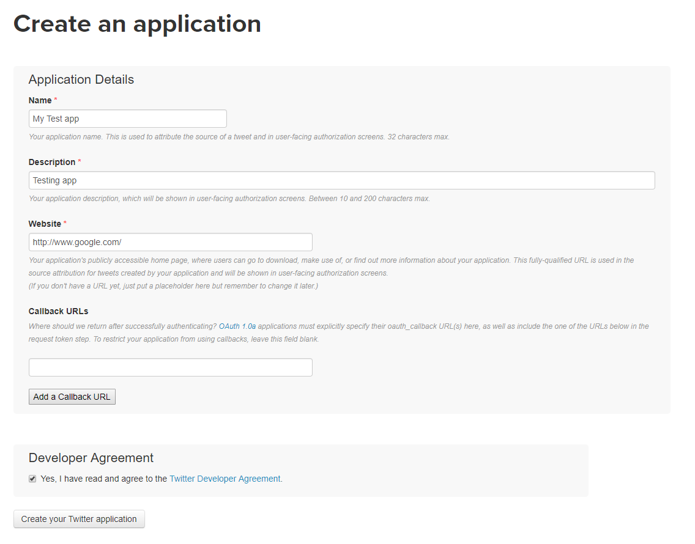

1. You can able to see the app details as shown below

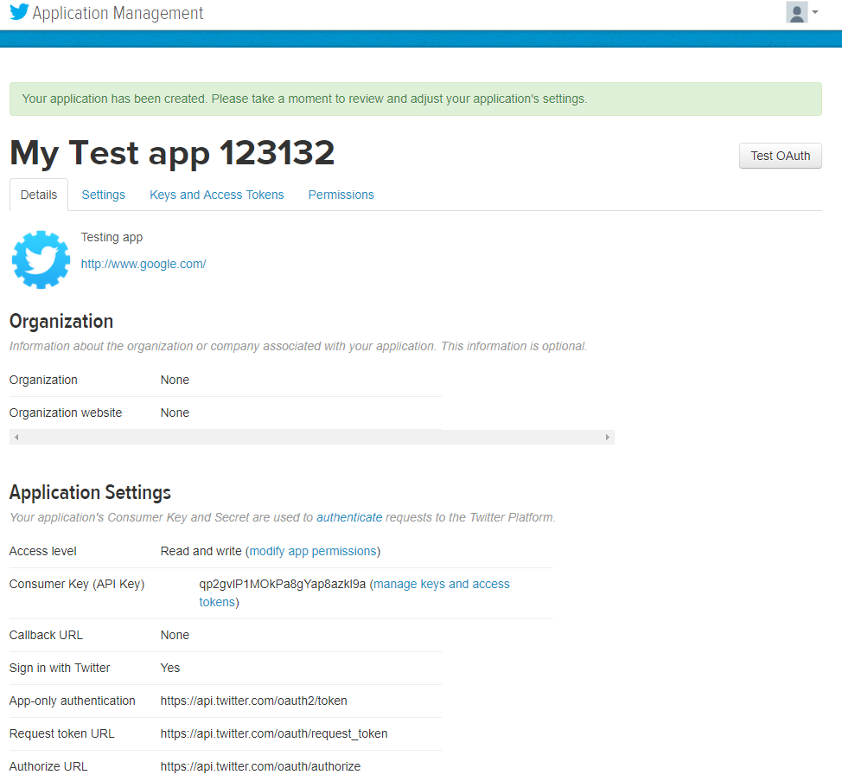

1. Go to **Keys and Access Tokens** Tab
2. Look for **Create and my access token** button and click on it

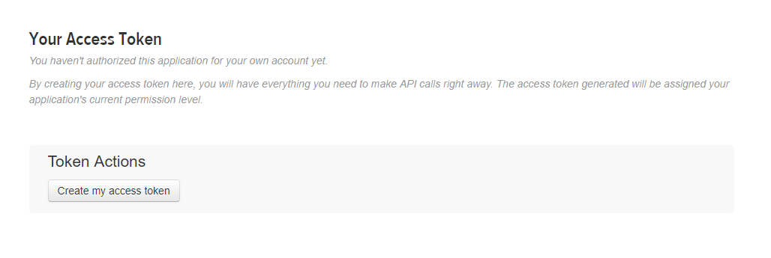

1. Make a note of OAuth Settings
   * Consumer Key
   * Consumer Secret
   * OAuth Access Token
   * OAuth Access Token Secret

# **Steps for execution**

1. Fork the repo - <https://github.com/GDP-MI7/socio-analyzer.git> and clone it.
2. Go to custom_analyzer folder
3. Open command prompt / Gitbash with current directory
4. Run **python dictionary_generation.py**
5. Run **python analyzer.py**
6. You will get output_analyzer.csv file.

# **Glossary of Errors**

1. Rate limit exceeded error

This error occurs due to twitter API limit for each 15 minutes window.

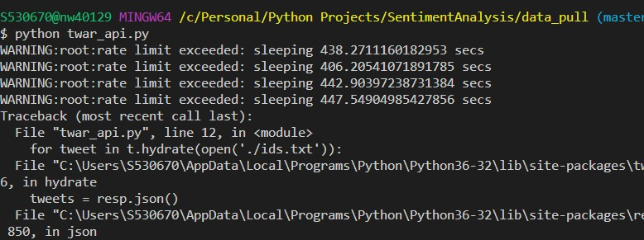

1. Module not found error

Solution: pip install <module_name> pip install pyquery

